**Project Design Phase-II**

**Solution Requirements (Functional & Non-functional)**

|  |  |
| --- | --- |
| Date | 13 May 2023 |
| Team ID | NM2023TMID21570 |
| Project Name | Empowering the Future: A literacy Rate Analysis for a Better Tomorrow |

**Technical Architecture:**

The deliverable shall include the architectural diagram as below and the information as per the table 1 & table 2

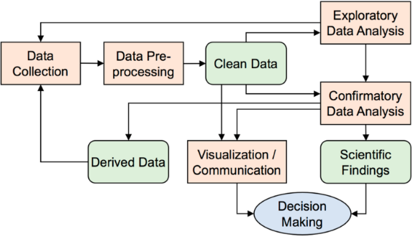

**Table-1: components & Technologies:**

|  |  |  |  |
| --- | --- | --- | --- |
| **S. No** | **Component** | **Description** | **Technology** |
| 1. | Programming Language | The language that provides a wide range of libraries and tools for machine learning and image processing. | Python |
| 2. | Dataset | A large and diverse dataset of literacy-related data required for training and evaluating the models. | Public datasets, government reports |
| 3. | Data Pre-processing | Pre-processing the dataset to clean, transform, and prepare it for analysis. | Python (pandas, NumPy), data wrangling tools |
| 4. | Data Visualization | Creating visual representations of the data to facilitate understanding and insights. | Tableau, Matplotlib, Plotly |
| 5. | Database Management | Storing and managing the collected data efficiently. | IBM DB2, IBM Cloudant, SQL databases |
| 6. | Cloud Deployment | Deploying the models and applications in a cloud environment for scalability and accessibility. | IBM Cloud, AWS, Microsoft Azure |
| 7. | File Storage | Managing file storage requirements for the project. | IBM Block Storage, Cloud storage |

**Table-2: Application Characteristics:**

|  |  |  |  |
| --- | --- | --- | --- |
| **S. No** | **Characteristics** | **Description** | **Technology** |
| 1. | Open-Source Frameworks | Utilizing open-source frameworks for performing deep learning tasks. | TensorFlow, Keras |
| 2. | Security Implementations | Implementing security measures such as user authentication and encryption. | AES (Advanced Encryption Standard). |
| 3. | Scalable Architecture | Designing a scalable architecture based on ResNet50 principles. | ResNet50 |
| 4. | Availability | Ensuring high availability through load balancers in cloud VPS. | IBM Cloud Hosting, Load Balancer |
| 5. | Performance | Performance depends on input data quantity, quality, and model complexity. | IBM Load Balancer |